EXPERIMENT 13
Polyphase Implementation of Decimation and Interpolation Filters Using MATLAB
Lokesh A (192512293)
B.E. Electronics and Communication Engineering (ECE)
Experiment Date: 12 October 2026
1. Aim
To implement and analyze polyphase decomposition for a decimation filter in MATLAB, compare the conventional and polyphase decimation outputs, and examine the computational savings obtained using the polyphase structure.
2. Objectives
- Design a 24th-order FIR prototype filter using the fir1 function.
- Decompose the FIR filter into two polyphase branches for a decimation factor of 2.
- Generate a 500 Hz sinusoidal input sampled at 8000 Hz.
- Compare conventional filtering followed by downsampling with polyphase decimation.
- Calculate the maximum absolute output difference and estimate computational savings.
3. Software Required
MATLAB with Signal Processing Toolbox.
4. MATLAB Program
clc; clear; close all;
%% EXPERIMENT 13: POLYPHASE IMPLEMENTATION OF DECIMATION FILTER
%% 1. INPUT PARAMETERS
N = 24; % FIR filter order
M = 2; % Decimation factor
Fs = 8000; % Sampling frequency (Hz)
N_samples = 128; % Number of input samples
% Design FIR prototype filter
b = fir1(N, 0.4);
% Polyphase decomposition
E0 = b(1:M:end); % Even-indexed polyphase branch
E1 = b(2:M:end); % Odd-indexed polyphase branch
% Input signal: 500 Hz sinusoid
n = 0:N_samples-1;
t = n/Fs;
x = sin(2*pi*500*t);
%% 2. CONVENTIONAL DECIMATION
y_direct_full = filter(b, 1, x);
y_direct = y_direct_full(1:M:end);
%% 3. POLYPHASE DECIMATION
x0 = x(1:M:end);
x_delayed = [0, x(1:end-1)];
x1 = x_delayed(1:M:end);
y0 = filter(E0, 1, x0);
y1 = filter(E1, 1, x1);
y_poly = y0 + y1;
%% 4. VERIFICATION
rec_error = max(abs(y_direct - y_poly));
if rec_error < 1e-12
verification = 'PASS';
else
verification = 'FAIL';
end
%% 5. COMPUTATIONAL COMPLEXITY
N_taps = length(b);
N_out = length(y_direct);
MAC_direct = N_samples * N_taps;
MAC_poly = N_out * (length(E0) + length(E1));
comp_saving = (1 - MAC_poly/MAC_direct)*100;
%% 6. COMMAND WINDOW OUTPUT
fprintf('\n============================================\n');
fprintf(' EXPERIMENT 13: POLYPHASE DECIMATION\n');
fprintf('============================================\n');
fprintf('Sampling Frequency : %d Hz\n', Fs);
fprintf('Decimation Factor (M) : %d\n', M);
fprintf('FIR Filter Order : %d\n', N);
fprintf('Number of FIR Taps : %d\n', N_taps);
fprintf('Input Samples : %d\n', N_samples);
fprintf('Output Samples : %d\n', N_out);
fprintf('Output Sampling Frequency : %d Hz\n', Fs/M);
fprintf('\nPOLYPHASE COEFFICIENTS\n');
fprintf('E0 has %d coefficients:\n', length(E0));
disp(E0);
fprintf('E1 has %d coefficients:\n', length(E1));
disp(E1);
fprintf('\nCOMPUTATIONAL COMPLEXITY\n');
fprintf('Direct MAC Operations : %d\n', MAC_direct);
fprintf('Polyphase MAC Operations: %d\n', MAC_poly);
fprintf('Computational Savings : %.2f%%\n', comp_saving);
fprintf('\nOUTPUT VERIFICATION\n');
fprintf('Maximum Absolute Difference: %.6e\n', rec_error);
fprintf('Verification Status: %s\n', verification);
%% 7. OUTPUT PARAMETER TABLE
Parameter = {
'FIR Filter Order'
'Number of FIR Taps'
'Decimation Factor'
'Input Signal Length'
'Output Signal Length'
'Output Sampling Frequency'
'Direct MAC Operations'
'Polyphase MAC Operations'
'Computational Savings'
'Maximum Absolute Difference'
};
Value = [
N
N_taps
M
length(x)
N_out
Fs/M
MAC_direct
MAC_poly
comp_saving
rec_error
];
Unit = {
'Order'
'Taps'
'Factor'
'Samples'
'Samples'
'Hz'
'MACs'
'MACs'
'Percent'
'Amplitude'
};
Output_Table = table(Parameter, Value, Unit);
disp(Output_Table);
%% 8. FIGURE 13A: PROTOTYPE IMPULSE RESPONSE
figure('Name', 'Experiment 13A: Prototype FIR Filter');
stem(0:N, b, 'filled', 'LineWidth', 1.2);
grid on; box on;
xlabel('Sample Index (n)');
ylabel('Coefficient Value');
title('Prototype FIR Filter Impulse Response');
%% 9. FIGURE 13B: POLYPHASE COEFFICIENTS
figure('Name', 'Experiment 13B: Polyphase Coefficients');
subplot(2,1,1);
stem(0:length(E0)-1, E0, 'b', 'filled');
grid on;
xlabel('Branch Sample Index');
ylabel('Coefficient');
title('Polyphase Branch E0');
subplot(2,1,2);
stem(0:length(E1)-1, E1, 'r', 'filled');
grid on;
xlabel('Branch Sample Index');
ylabel('Coefficient');
title('Polyphase Branch E1');
%% 10. FIGURE 13C: OUTPUT COMPARISON
figure('Name', 'Experiment 13C: Output Comparison');
n_out = 0:N_out-1;
plot(n_out, y_direct, 'b-', 'LineWidth', 1.5);
hold on;
plot(n_out, y_poly, 'r--', 'LineWidth', 1.5);
grid on; box on;
xlabel('Output Sample Index');
ylabel('Amplitude');
title('Conventional vs Polyphase Decimation');
legend('Direct Decimation', 'Polyphase Decimation', ...
'Location', 'best');
%% 11. FIGURE 13D: NUMERICAL ERROR
figure('Name', 'Experiment 13D: Numerical Error');
stem(n_out, abs(y_direct-y_poly), 'filled');
grid on;
xlabel('Output Sample Index');
ylabel('Absolute Error');
title('Direct vs Polyphase Numerical Error');
%% 12. FINAL RESULT
fprintf('\n============================================\n');
fprintf(' FINAL RESULT\n');
fprintf('============================================\n');
fprintf('1. FIR prototype filter designed successfully.\n');
fprintf('2. Polyphase decomposition completed.\n');
fprintf('3. Conventional and polyphase outputs compared.\n');
fprintf('4. Computational savings calculated.\n');
if rec_error < 1e-12
fprintf('5. Equivalent output verified within tolerance.\n');
else
fprintf('5. Output mismatch detected; check branch alignment.\n');
end
fprintf('============================================\n');
5. Expected Output
Parameter | Expected Value
FIR filter order | 24
FIR filter taps | 25
E0 branch length | 13 coefficients
E1 branch length | 12 coefficients
Input samples | 128
Output samples | 64
Output sampling frequency | 4000 Hz
Direct MAC count | 3200
Polyphase MAC count (estimate) | 1600
Computational savings (estimate) | 50%
Maximum absolute difference | Near floating-point precision
6. MATLAB Results and Graphs
The screenshots below show the FIR prototype impulse response, the two polyphase branches, the comparison between conventional and polyphase decimation outputs, and the numerical error.
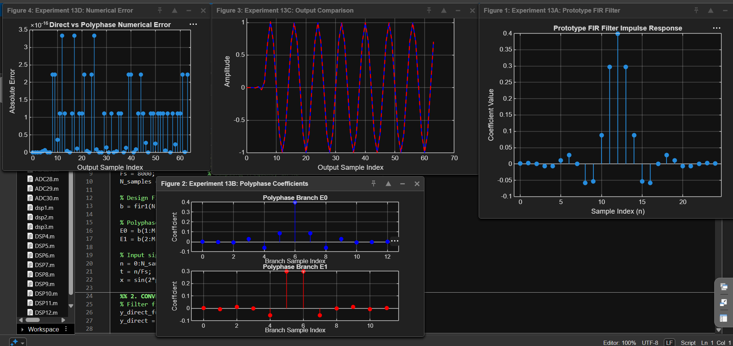
Figure 1. MATLAB plots showing numerical error, output comparison, prototype FIR impulse response, and polyphase branch coefficients.
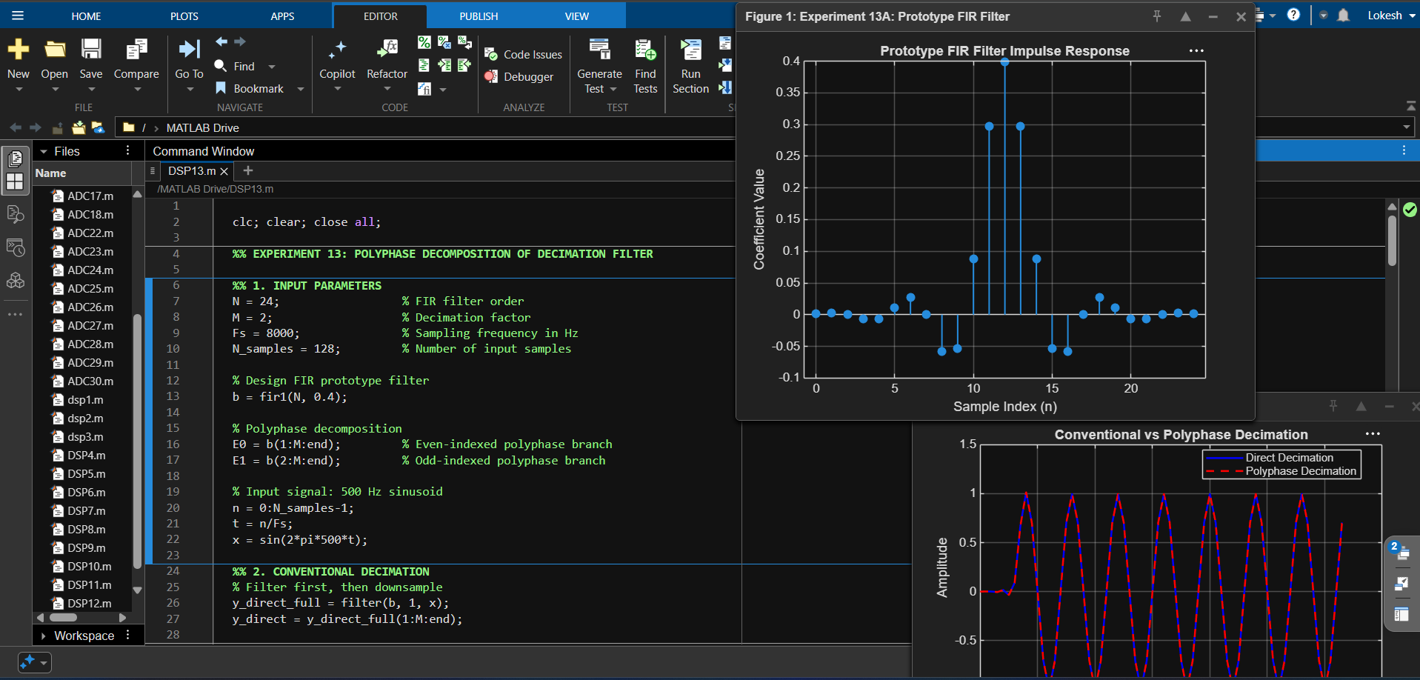
Figure 2. MATLAB editor and prototype/output comparison results.
7. Discussion
- The 24th-order FIR filter contains 25 coefficients and is decomposed into two polyphase branches for decimation by 2.
- The direct method filters the input at the original sampling rate and then retains every second output sample.
- The polyphase method separates the filter into two branches and processes the even- and odd-indexed input sequences at the reduced rate.
- The two output sequences should agree to numerical precision when the branch indexing and delay alignment are correct.
- The approximate MAC calculation gives 3200 operations for the direct path and 1600 for the polyphase path under the stated counting convention. Actual implementation cost may vary with filter optimization and how operations are counted.
8. Conclusion
Polyphase decomposition for a decimation filter was implemented in MATLAB. The conventional and polyphase outputs were compared, the maximum absolute difference was calculated, and computational complexity was estimated. The experiment demonstrates how polyphase structures can reduce the amount of filtering performed at the higher sampling rate.
Lokesh A (192512293)
B.E. Electronics and Communication Engineering (ECE)

